Restoring Database from Microsoft Azure Blob Block Storage
Overview
The purpose of this document is to provide step by step instructions on how to restore database from Microsoft Azure Blob Storage Service. There are two types of blobs that can be stored in Microsoft Azure Blob storage service: block and page blobs. This document is limited to discuss on restoring database from block blob storage service.
If you are interested to restore database from block blob, you should have Shared Access Signature (SAS) because BACKUP to a block blob requires SAS that saved in a SQL Server credential. This document will outline the necessary steps to restore database from Block Blob storage using SAS which includes how to login to Azure portal from local working station, retrieve SAS token, create credential using SAS and finally restoring database using GUI or t-SQL . Restoring database from Microsoft azure blob block storage requires SQLDBA team to follow the following three basic steps:
Step 1: Retrieve SAS token of full-bkup-block container/tlog-bkup-block
SQL Server backup and restore processes use credential to authenticate to the Microsoft Azure Blob storage service and its container and blob objects. The block blob credential stores container URL and its SAS token therefore it is necessary to retrieve SAS token of full-bkup-block container/tlog-bkup-block before executing the syntax of RESTORE statements. If you are interested to restore only full back up, you only need to retrieve SAS token from full-bkup-block container. However if you are interested to restore both full and tlog back up, you also need to retrieve SAS token from tlog-bkup-block container. Use the below PowerShell script to retrieve the existing SAS.
### login to the portal
Login-AzureRmAccount
### Common code to retrieve sAS token
$subscriptionName='your-subscription-here'
$resourceGroupName='your-resource-group-here' # Set a variable for the name of the resource group you will create or use
$storageAccountName= 'backup-storage-here' # the storage account name you will create or use
$policyName = $storageAccountName # the name of storage account name (foreasier usage)
$fullBkupContainerName = 'full-bkup-block' # the storage container name to which you will attach the SAS policy with its SAS token
$logBkupContainerName = 'tlog-bkup-block'
# set the tenant, subscription and environment for use in the rest of
Set-AzureRmContext -SubscriptionName $subscriptionName
# Get the access keys for the ARM storage account
$accountKeys = Get-AzureRmStorageAccountKey -ResourceGroupName $resourceGroupName -Name $storageAccountName
# Create a new storage account context using an ARM storage account
$storageContext = New-AzureStorageContext -StorageAccountName $storageAccountName -StorageAccountKey $accountKeys[0].Value
######## Storage Account key
Write-Host 'Storage Account Name:'$storageAccountName''
Write-Host 'Storage Account Key 1:'$accountKeys[0].Value''
######## full-bkup-block Container SAS Token for Full Backup
# Get Full backup container in blob storage
$fullBkupContainer = Get-AzureStorageContainer -Context $storageContext -Name $fullBkupContainerName
$fullBkupcbc = $fullBkupContainer.CloudBlobContainer
# Gets the Shared Access Signature for the policy
$policy = new-object 'Microsoft.WindowsAzure.Storage.Blob.SharedAccessBlobPolicy'
$fullBkupSASToken = $fullBkupcbc.GetSharedAccessSignature($policy, $policyName)
$FullBkupBlockTokenPrimary = $fullBkupSASToken.Substring(1)
Write-Host 'full-bkup-block SAS Token:'$($fullBkupSASToken.Substring(1))''
######## log-bkup-block Container SAS Token for log Backup
# Get Log backup container in blob storage
$logBkupContainer = Get-AzureStorageContainer -Context $storageContext -Name $logBkupContainerName
$logBkupcbc = $logBkupContainer.CloudBlobContainer
# Gets the Shared Access Signature for the policy
$policy = new-object 'Microsoft.WindowsAzure.Storage.Blob.SharedAccessBlobPolicy'
$logBkupSASToken = $logBkupcbc.GetSharedAccessSignature($policy, $policyName)
$logBkupBlockTokenPrimary = $logBkupSASToken.Substring(1)
Write-Host 'log-bkup-block SAS Token:'$($logBkupSASToken.Substring(1))''
If you want to implement Azure related tasks from local station, you need to install Azure PowerShell on your machine. Follow the steps to install Azure PowerShell on your machine https://docs.microsoft.com/en-us/powershell/azure/install-azurerm-ps?view=azurermps-6.5.0
Step 2: Create Credential on the target SQL instance where you are going to restore the database
- Credential Name: https:// < storage account name here> .blob.core.windows.net/full-bkup-block
- Identity : SHARED ACCESS SIGNATURE
- Password : SAS token
Remember: a SQL Server credential is an object that is used to store authentication information required to connect to a resource outside of SQL Server. So if you are interested to restore database on the same server from where the backup is configured to send to block blob, there is no need to create credential because the backup and restore processes will use same credential to authenticate to the Microsoft Azure block blob. Just go to step 3 for such case. Creating credential is mandatory if you are interested to restore database from one environment to another environment where they do not have same credential. Backup and restore TDE certification for database encrypted may also be required if necessary in addition to credentials
How to Create Credential: It is possible to create credential either using GUI or t-sql
Using GUI
Go to security > Credential > Right-click Credential and select New Credential
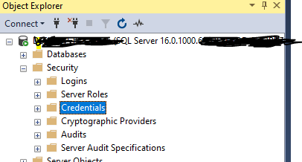
Pass the following value
- Credential Name: https:// < storage account name here> .blob.core.windows.net/full-bkup-block
- Identity : SHARED ACCESS SIGNATURE
- Password : SAS token
- Confirm Password : SAS token

See example below. This credential is created on different server (let us say ABCDSQ1) using storage account and SAS token of XYZSQ1\SQL1 server. Here the target is we are interested to restore Database backed up from server XYZSQ1\SQL1 to ABCDSQ1\SQL1
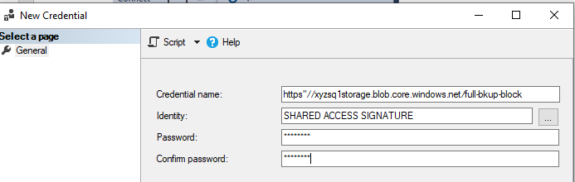
t-SQL
Use the following script to create a SAS credential - providing the URL for the storage account container and the SAS key as indicated
IF NOT EXISTS
(SELECT * FROM sys.credentials
WHERE name = 'https://<storageaccountname>.blob.core.windows.net/<containername>')
CREATE CREDENTIAL [https://<storageaccountname>.blob.core.windows.net/<containername>]
WITH IDENTITY = 'SHARED ACCESS SIGNATURE',
SECRET = '<SAS_TOKEN>';
Example
USE [master]
GO
IF NOT EXISTS (SELECT * FROM sys.credentials WHERE name = 'https://xyzsq1storage.blob.core.windows.net/full-bkup-block ')
CREATE CREDENTIAL [https://xyzsq1storage.blob.core.windows.net/full-bkup-block]
WITH IDENTITY = N'SHARED ACCESS SIGNATURE',
SECRET = N'henoktsv=2017-07-29&sr=c&si=xyzsq1storage=ORDRMi0Lh%%3D'
Go
Step 3 :Restoring from Microsoft Azure storage Using SQL Server Management Studio
The Restore Database task includes URL as a device to restore from. The following steps describe using the Restore task to restore from the Microsoft Azure Blob storage service using GUI (2016 and above) or using t-sql
Right-click Databases and select Restore Database....
On the General page, select Device under the Source section. Click the browse (...) button to open the Select backup devices dialog box
Select URL from the Backup media type: drop-down list. Click Add to open the Select a Backup File Location dialog box
Select backup File Location
Click on Azure storage container drop down and select the pre-registered container from the drop down or manually enter the fully qualified container name and pass SAS token on Shared Access Signature Box and then click Ok.
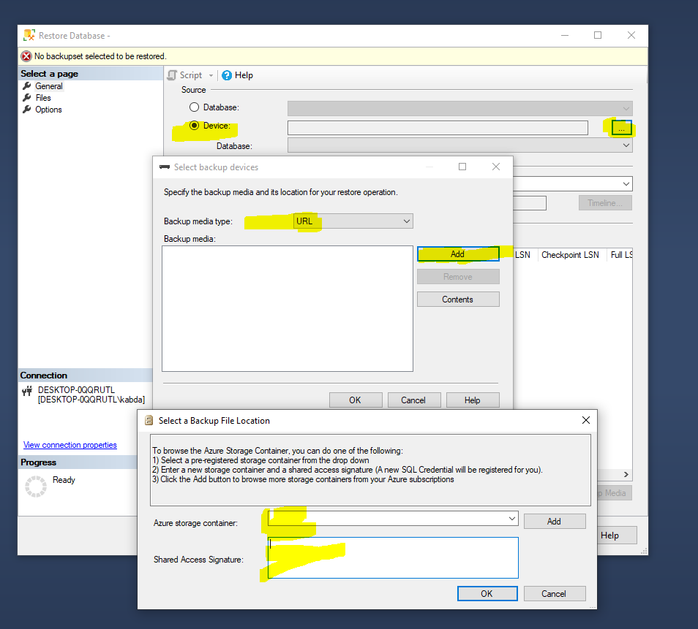

SQL Server connects to Microsoft Azure storage using the SQL Credential information you provided and opens the Locate Backup File in Microsoft Azure dialog.

Remember if you create credential correctly, this is the step where you will see the Azure Storage Container of the other server.
The backup files residing in the storage container are displayed on this page. Select the file you want to use to restore and click OK. Example: DBAdmin_20230807_043000.BAK
This takes you back to the Select Backup Devices dialog where URL, Backup file location and bak file being selected. Click Ok
Clicking OK takes you back to the main Restore dialog where you will be able modify on files and options and then complete the restore
You can also script out and may schedule if the DB is Big. Example If I want to change the DB name and move the file to other location with t-sql
USE [master]
RESTORE DATABASE [DBAdmin]
FROM URL = N''https://xyzsq1storage.blob.core.windows.net/full-bkup-block/ DBAdmin_20230807_043000.BAK' WITH FILE = 1,
MOVE N'DBAdmin' TO N'G:\DATA\DBAdmin.mdf',
MOVE N'DBAdmin_log' TO N'G:\DATA\DBAdmin_log.ldf'
GO
If everything is okay - DB will be restored successfully

Additional reference: Perform on-premises SQL Server database backups using maintenance plans to Azure Blob Storage (mssqltips.com)

Restoring database from soft-deleted blob files
If database needs to be restored from previously "soft-deleted" (but within retention time) files, follow this process.
1- In Azure portal navigate to the storage account where files are located, proceed to proper container, and toggle switch "Show deleted blobs" in upper right corner. You should see files with both available statuses: Active and Deleted

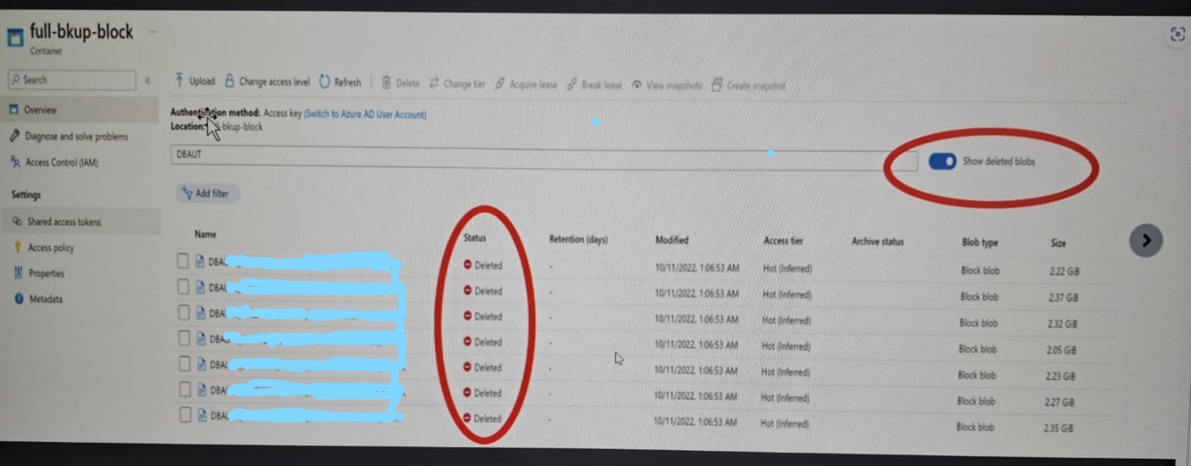
Make sure if see the files you need to recover database from. If you don't see the files, it means they were permanently deleted by Azure after exceeding retention time for "soft deleted files".
To check current setting for soft deletion , navigate in Azure portal to Data protection section for a chosen storage account and observe current settings for retention of soft deleted blobs.

2- Select all "soft deleted" files that will be used for database recovery,
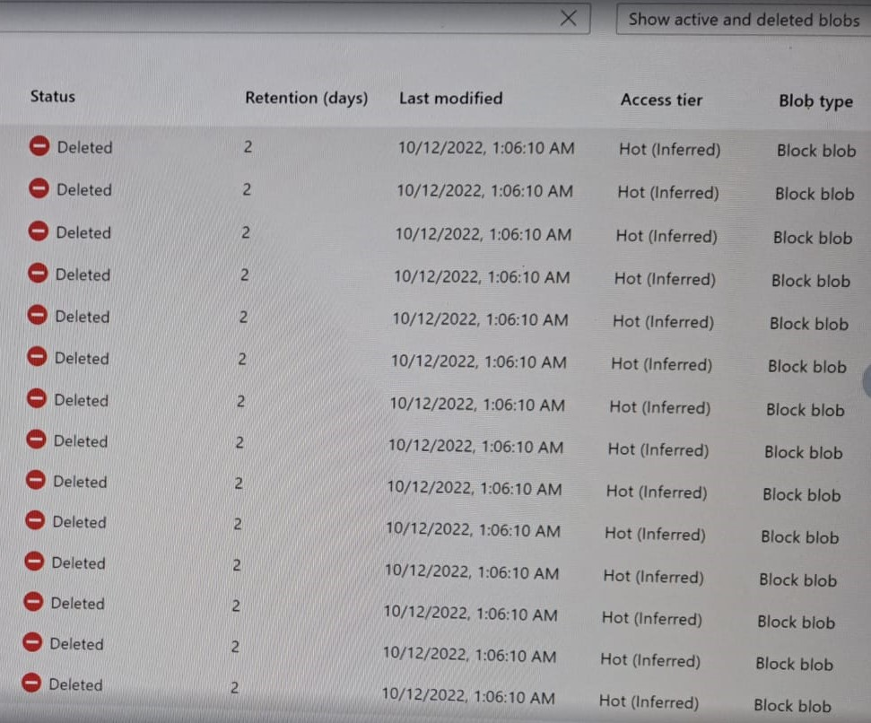

Scroll to the very far right of the screen to make row context menu visible, and select option Undelete
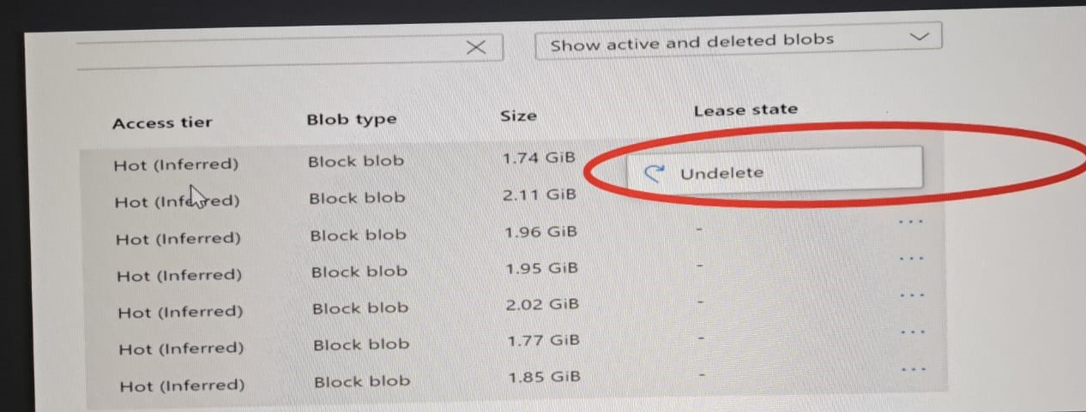
All files became undeleted with status Active
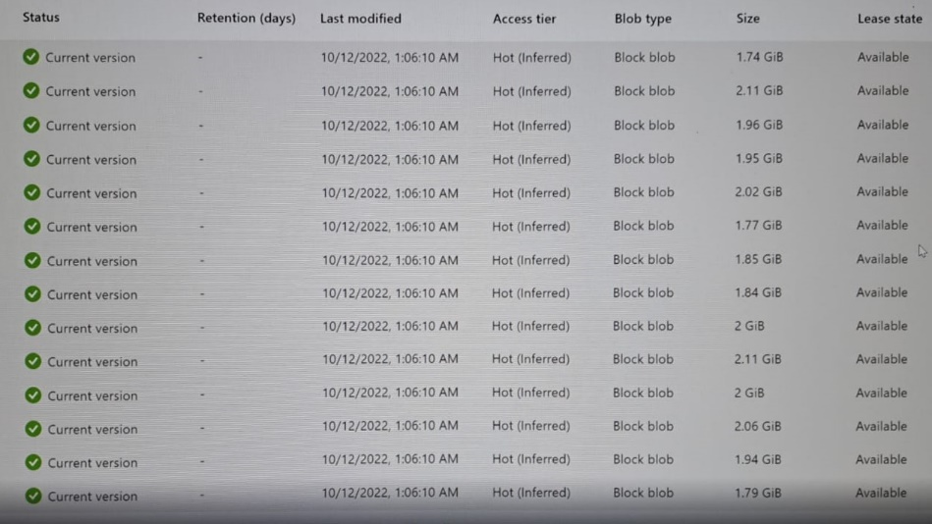
3- Follow standard process to restore databases from files:
In target server open Command PrompCopy filest in elevated mode and run AzCopy to copy needed files to local storage

